PATIENT INFORMATION:
Name: ______________________________________
Age: ________ Date of Birth: _____________________ Male Female
Married Divorced Single Separated Widowed Domestic Partner
Address: _______________________________ City: _________________ State: ______ Zip: __________
Home phone: ________________ Work phone: ________________ Cell Phone: ________________
Email: _______________________________________
Occupation: __________________________ Employer: _________________________________
RESPONSIBLE PARTY (if under the age of 18):
Name of responsible party: _________________ Relationship: _________________
Address: _______________________________ City: _________________ State: ______ Zip: __________
Home phone: ________________ Work phone: ________________ Cell Phone: ________________
Email: _______________________________________
INSURANCE INFORMATION: Company: _______________________________
Subscriber Name: _________________ ID #: ____________________________
Address: _______________________________ City: _________________ State: ______ Zip: __________
Customer service phone number: _________________
Subscriber date of birth: _________________ Relationship to subscriber: _____________________
EMERGENCY CONTACT / NEXT OF KIN:
Name: __________________________ Phone: _________________ Relationship: ________________
Name: __________________________ Phone: _________________ Relationship: ________________
Information for your Acupuncturist
Important: Complete this page and the Health History document as thoroughly as possible. Some of the questions that follow may seem unrelated to your condition, but they may play a major role in diagnosis and treatment.
All information is strictly confidential.

Name of your primary physician: ___________________________ Location: _____________________
Is there anything limiting you from care? No Yes Explain: _______________________
Other physicians/therapists seen for the condition: ______________________________________
How did you hear about our office? ______________________________________
Medications you are current taking:
1) _________________ 2) _________________ 3) _________________ 4) _________________
5) _________________ 6) _________________ 7) _________________ 8) _________________
Prescribed by: ____________________________________________________________________
For Treatment of: _________________________________________________________________
Results: _________________________________________________________________________
Supplements (if any, vitamins, herbs, minerals, etc.)________________________________________
__________________________________________________________________________________
Major Issue(s), in order of significance to you:
- ___________________________ 4. ___________________________
- ___________________________ 5. ___________________________
- ___________________________ Additional: ___________________________
How do these issues impair your daily activities? __________________________________________________________________________________________________________________________________________________________________________
Dear New Patient:
- Please read and fill in all of the information that pertains to you.
- On numbers 2 through 14, under each category, check all symptoms that you experience either acutely (affect you now) or chronically (affect you in general).

TEST DATE TEST RESULTS

Physical _______ __________________________________________________________________

Cholesterol _______ __________________________________________________________________

Prostate _______ __________________________________________________________________

Mammography _______ __________________________________________________________________

Pap Smear _______ __________________________________________________________________

Blood (which test?) _______ __________________________________________________________________

HIV/STD _______ __________________________________________________________________

Other _______ __________________________________________________________________
Please indicate if you have (or had) any of the following.

Diabetes
Heart Disease
Asthma
High Blood Pressure
Syphilis
Meningitis
Epilepsy
Paralysis
Glaucoma

Allergies
CVA (stroke)
Pneumonia
Gonorrhea
Measles
HIV
High Fever
Cancer
Mumps

Rheumatic Fever
Thyroid Disorder
Emphysema
Bleeding Tendency
Nervous Disorder
Mononucleosis
Multiple Sclerosis
Jaundice
Hepatitis

Vein Condition
Tuberculosis
Chicken Pox
Polio
Migraines
Other Liver Illnesses
Other Heart Illnesses
Other Kidney Illnesses
Other Lung Illnesse

IMMUNIZATIONS?
SURGERIES?

1. Pain

What makes the pain better?
Soft Pressure
Hard Pressure
Cold
Heat
Exercise
Rest
Other
What makes the pain worse? Please mark your pain on the diagram below.
Soft Pressure
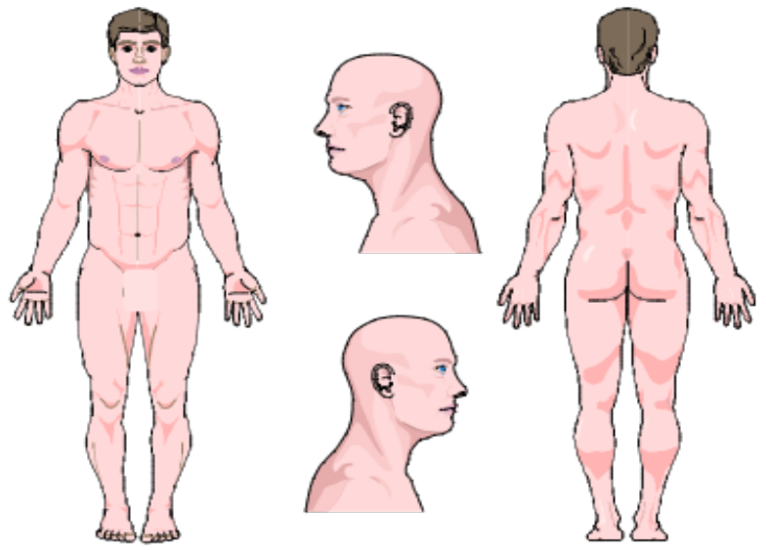
Hard Pressure
Cold
Heat
Exercise
Rest
Other

2. Describe Your Pain

Sharp
Fixed
Burning
Moving
Cramping
Aching
Dull
Other: _________________

3. Kidney Function
(Overall Temperature)

Cold Hands
Cold Fingers
Cold Feet
Sweaty Hands
Sweaty Feet
Hot Body Temperature Sensations
Cold Body Temperature Sensations
Thirsty
Perspire Easily
Lack of perspiration

4. Lung and Kidney Function
(Overall Energy)

Shortness of Breath
Difficulty Keeping Eyes Open (Daytime)
General Weakness
Easily Catch Colds
Low Energy
Feel Worse After Exercise
Chronic Daily Fatigue & Malaise

5. Heart Function

Sores On Tips of Tongue
Restlessness
Mental Confusion
Chest Pain Traveling to Shoulder
Frequent Dreams
Wake Unrefreshed
Coffee? How Much Per Week? ________

6. Lung Function

Nasal Discharge (color________)
Cough
Nose Bleeds
Sinus Congestion
Dry Mouth
Dry Nose
Dry Throat
Dry Skin
Allergies
Alternating Chills / Fever
Sneezing
Headache (location ________)
Overall achy feeling in body
Stiff Neck
Stiff Shoulders
Sore Throat
Difficulty Breathing
Smoke Cigarettes (# per day________)
Sadness
Melancholy

7. Spleen Function

Low Appetite
Abrupt Weight Gain
Abrupt Weight Loss
Abdominal Bloating
Abdominal Gas
Gurgling Noise in Stomach
Fatigue After Eating
Prolapsed Organs? Which? ________
Bruise Easily?
Over-Thinking
Worry

8. Spleen / Stomach Function
(Small / Large Intestine)
Loose Stools
Constipation
Incomplete Stools
Diarrhea
Blood in Stools
Mucous in Stools
Undigested Food in Stools
9. Stomach Function
Burning Sensation after Eating
Large Appetite
Bad Breath
Canker Sores (Mouth)
Bleeding, Swollen or Painful Gums
Heart Burn
Acid Regurgitation
Ulcer (Diagnosed? ________)
Belching
Hiccups
Stomach Pain
Vomiting

10. Dampness Trapped in the Body
Bodily Sensation of Heaviness
Mental Heaviness
Mental Sluggishness
Mental fogginess
Swollen Hands
Swollen Feet
Swollen Joints
Chest Congestion
Nausea
Snoring

11. Liver, Gall Bladder Function

Alternating Diarrhea & Constipation
Chest Pain
Tight Sensation in the Chest
Bitter Taste in the Mouth
Anger Easily
Anxiety
Depression
Frustration
Irritability
Skin Rash
Headache at the Top of the Head
Tingling Sensation
Numbness
Cold Hands
Cold Fingers
Cold Feet
Dizziness
See Floating Black Spots
Muscle Twitching
Muscle Cramping
Muscle Spasms
Seizures
Convulsions
Lump in Throat
Neck Tension
Shoulder Tension
Limited Range-of-Motions (Neck)
Limited Range-of-Motions (Shoulder)
How much Alcohol? ____/________
Recreational Drugs?
High Pitched Ringing in Ears
Gallstones
STD’s (Which? ________)
Unable to Adapt to Stress

12. Liver Function (eyes)
Itching
Bloodshot
Hot
Dry
Watery
Gritty
Blurry Vision
Decreased Night Vision
Near - Sighted
Far - Sighte

13. Kidney, Urinary Bladder Function

Frequent Cavities, Teeth Problems
Easily Broken Bones
Sore Knees
Weak Knees
Cold Sensation in the Knees
Low Back Pain
Memory Problems
Excessive Hair Loss
Low-Pitched Ringing in the Ears
Kidney Stones
Bladder Infections
Lack of Bladder Control
Wake to Urinate 2 or More Times
Fear
Easily Startled
Low Libido

14. Urination (Bladder Function)
Yellow
Reddish
Cloudy
Scanty
Profuse
Strong Odor
Burning
Painful
Discharge
Difficult
Urgent
Frequent

Men Only

Swollen Testes
Testicular Pain
Impotence
Premature Ejaculation
Feeling of Coldness in Genitalia
Other? ________

Women Only

Nausea
Vomiting
Food Cravings
Water Retention
Breast Swelling
Breast Tenderness
Headaches
Migraines
Dull Pain (Where? ________)
Sharp Pain (Where? ________)
Depression
Irritability
Anxiety
Heavy Menstrual Flow
Blood Clots
Pale Blood
Purple Blood
Other (Explain: ________)

Do you have a regular menstrual cycle? Yes No
Are you pregnant? Yes No
Do you have bleeding between periods? Yes No
Do you have vaginal discharge? Yes No

Please Fill In The Menstrual Chart:
________ Age of first menstruation
________ Average number of days of menstrual flow
________ Number of days in entire cycle (1st day to 1st day)
________ Number of children
________ Number of pregnancies
________ Age of menopause (if applicable)

 | Day 1 | Day 2 | Day 3 | Day 4 | Day 5 | Day 6 | Day 7
Color:
Amount Of Flow:
Pain/Cramps:
Location of Cramps:
Vomiting (Check If Yes):
Nausea (Check If Yes):

Agreement By The Patient / Garantor To Be Financially Responsible For Fees

I (patient or guarantor) understand that I am financially responsible for all charges whether or not paid by my insurance. I am aware that some and perhaps all of the services provided may be non-covered services under my insurance. I am also aware that verification of insurance benefits is not a guarantee of payment. I also understand that a monthly interest rate of 1.5% will be applied to any unpaid patient balance over 30 days past due. Initial: ________

Agreement By The Patient Regarding Cancelled/Missed Appointments

Patient understands that a missed appointment (No Show) will result in full charges being issued for that appointment. If a patient fails to give the clinic 24 hours notice of a change of appointment, the patient may be charged for that appointment. Initial :________

Medical Release To Insurance Company & Referring Physicians

I authorize the release of medical information to my insurance company / companies and referring physician, including diagnosis and the record of treatment or examinations rendered to me during the period of such medical care, and also request my insurance company / companies to pay directly to Alpine Acupuncture for those medical services. Initial: ________

Notice Of Privacy Practices – Acknowledgement

- We keep a record of the health care services we provide you.
- You may ask to see and copy that record.
- You may also ask to correct that record.
- We will not disclose your record to others unless you direct us to do so, or unless the law authorizes or compels us to do so.
- You may see your record or get more information about it by contacting the Office Manager / HIPAA Officer.

Our Notice of Privacy Practices describes in more detail how your health information may be used and disclosed, and how you can access your information. You acknowledge that you have been provided with a copy of our Notice of Privacy Practices to read. Initial: ________

______________________________________ ______________
Patient or legally authorized individual signature Date

______________________________________ __________________
Printed name and signed on behalf of the patient Relationship (Parent, legal guardian, representative)

__________________________________________________________________
Witness/Staff Member
Patient Notification of Qualifications and Scope of Practice
I voluntarily consent to be treated by Alpine Acupuncture using East Asian Medicine. This Clinic offers several treatment modalities. The course of the treatment will be determined between the health practitioner and myself. East Asian medicine means a health care service using East Asian medicine diagnosis and treatment to promote health and treat organic or functional disorders.
The scope of practice for an East Asian medicine practitioner in the state of Washington includes the following:
(a) Acupuncture, including the use of acupuncture needles or lancets to directly or indirectly stimulate acupuncture points and meridians;
(b) Use of electrical, mechanical, or magnetic devices to stimulate acupuncture points and meridians;
(c) Moxibustion;
(d) Acupressure;
(e) Cupping;
(f) Dermal friction technique;
(g) Infra-red;
(h) Sonopuncture;
(i) Laserpuncture;
(j) Point injection therapy (aquapuncture);
(k) Dietary advice and health education based on East Asian medical theory, including the
recommendation and sale of herbs, vitamins, minerals, and dietary and nutritional supplements;
(l) Breathing, relaxation, and East Asian exercise techniques;
(m) Qi gong;
(n) East Asian massage and Tui Na, which is a method of East Asian bodywork, characterized by the kneading, pressing, rolling, shaking, and stretching of the body and does not include spinal manipulation;
(o) Superficial heat and cold therapies.
I acknowledge that there are some risks to the treatment. These side effects may include, but are not limited to the following:
(a) Pain following treatment;
(b) Minor bruising;
(c) Infection;
(d) Needle sickness; and
(e) Broken needle.
The patient must inform the East Asian medicine practitioner if the patient has a severe bleeding disorder or pacemaker prior to any treatment.
Carleton Magus received his Master’s Degree in Acupuncture and Oriental Medicine form Bastyr University in 2006. He is nationally board certified by the National Certification Commission for Acupuncture and Oriental Medicine. And he is a Licensed Acupuncturist in the State of Washington, holding Acupuncture License number 3000, active from 02/05/2007 to the present.

____________________ ______________
Patient or legally authorized individual signature Date

______________________________________ __________________
Printed name and signed on behalf of the patient Relationship (Parent, legal guardian, representative)

